Instructions for data import from Masslynx into UNIFI (1.9 service release 3)

UNIFI offers direct data import of Masslynx .raw data files. Instructions for importing data are provided as follows:

Step 1. Click the dropdown arrow of the main menu, a panel shown in Figure A will appear. Choose "Tools","Import Masslynx data". A new dialog "Create Import Task" shown in Figure B will appear. From this dialog, one can choose either "Masslynx raw folders" for importing data only (*.RAW), or "Masslynx SPL files" for importing through a Masslynx sample list file (*.SPL). The advantage of using the sample list file type is that the injection sequence of the imported samples is the same as the original.
With the "Masslynx SPL file" import type chosen, one can import directly from a Masslynx.PRO project folder or from copied data. Note: in the case of copied data, the sample list file .SPL needs to reside in a folder called "SampleDB", and .raw files need to reside in a folder called "Data" as shown in Figure B (right). In this way, the sample list will correctly associate each entry with a data file.

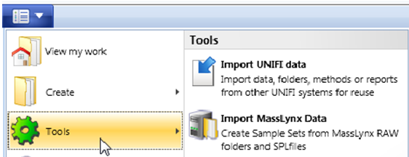
Figure A. Panel from Main Menu.
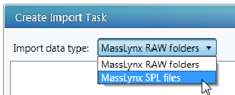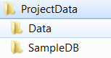
Figure B. (left) Import data type choices from "Import Masslynx Data" (right) Minimum folder structure for using "Masslynx SPL files" import data type. The Data folder contains .raw files, and the SampleDB folder contains .SPL files.

Step 2. With choosing the "Masslynx SPL data files", click the "+" button, a file browsing window will appear (not shown). Browse to the .SPL file location and click OK, the sample list file and corresponding .raw data files will populate the left panel of Figure C. Choose a destination folder and enter the sample set name, pressing the "Create UNIFI Sample Set" button will start the import. A green bar shown in the right panel shows the progression of the import.

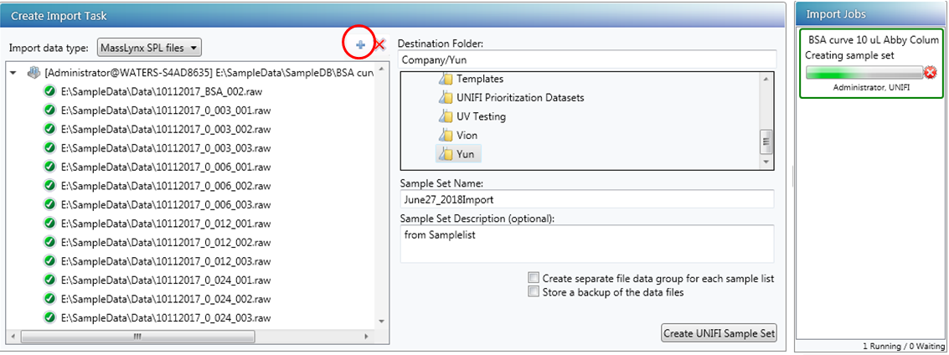
Figure C. Data import for "Masslynx SPL Files" data type.
Step 3. After the import is completed, the files will appear in UNIFI Explorer with the sample set format. The user can then create an analysis and perform data processing.

