UNIFI is a service based application that uses Microsoft’s Windows Communication Foundation (WCF) framework. This allows clients and services to communicate via TCP/IP and HTTP either over a network or locally on the same machine.
UNIFI Services are hosted within a ‘Waters.ServiceHost.exe’ process on the Application Server and LND tiers. There are a number of ‘Waters.ServiceHost.exe’ processes running. One of these processes acts as the ‘main’ Service Host while the others are child processes of the main process. The main Service Host is executed as a Windows Service.
Each of the Waters.ServiceHost.exe processes contains a group of UNIFI Services. UNIFI Services that are hosted within the same process as configured to be part of the same ‘Process Pool’. UNIFI Services are configured so that heavy-weight services (such as Processing and Reporting) that can consume high levels of system resources are isolated within their process.
The table below shows the Windows services running on a UNIFI App Server.
Service Name | Description
Waters Service Host | The UNIFI Service Host Windows Service. This service controls the main Waters.ServiceHost.exe process.
Waters Database Manager Listener
Waters DHCP Server | DHCP Server used for instruments.
Waters Metrics Publisher | Publishes internal metrics
Waters.Acquisition.FileService
OracleASM12cTNSListener | Oracle TNS Listener service. Manages client connection requests to the database.
OracleASMService+ASM | Oracle Automatic Storage Management (ASM) service.
OracleJobSchedulerUNIFI
OracleOHService
OracleServiceUNIFI | The Oracle instance

The table below shows the typical processes that will be running.
Process Command Line  (all in C:\Program Files\Waters\UNIFI\Server\Bin\..) | Description
.\Waters.ServiceHost.exe | Main service host process.  Host all lightweight services
.\Waters.ServiceHost.exe" /procPoolName:AFW /mainProcID:924 | Hosts Analysis Center WCF services
.\Waters.ServiceHost.exe" /procPoolName:AWB /mainProcID:924 | Hosts Analytical Workbench WCF services
.\Waters.ServiceHost.exe" /procPoolName:Processing /mainProcID:924 | Hosts Processing WCF service
.\Waters.ServiceHost.exe" /procPoolName:Reporting /mainProcID:924 | Hosts Reporting WCF service
.\Waters.ServiceHost.exe" /procPoolName:Workflow /mainProcID:924 | Hosts Windows Workflow Windows service
.\Waters.ServiceHost.exe" /procPoolName:JobScheduler /mainProcID:924 | Hosts Job Scheduler WCF service
.\Waters.Portal.exe | The UNIFI UI executable. This may be running on any of the client machines.

UNIFI Processes as view via Task Manager
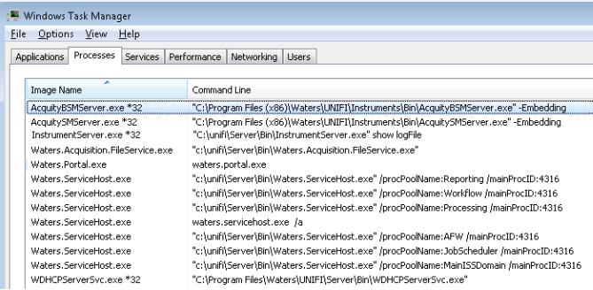

UNIFI Services as view via Task Manager
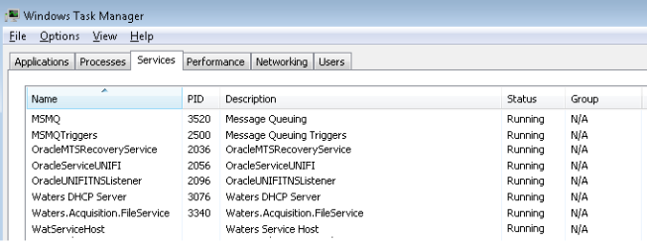
On a workgroup server the additional Oracle services will be present

